|  |  |
| --- | --- |
| When  Thursday, February 22, 2024  6 to 8 pm  Where  Historic Central Hotel  171 N Broadway, Burns  What  Audit Report  Local Conservation Achievements  Guest Speaker on V Fencing  Roundtable Discussion | Dinner  Provided by Kathi Wenick  (RSVP by February 16)  Door prizes  Charlotte Ganskopp  Dave Ganskopp  CWMA  HSWCD  Special Recognition  Jerry Miller |

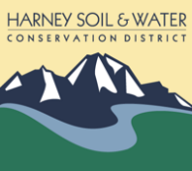

Harney Soil & Water Conservation District

Annual Landowner Meeting

ANNUAL MEETING