**Malheur Strategic Implementation Area Monitoring Project**

**Open for Bid**

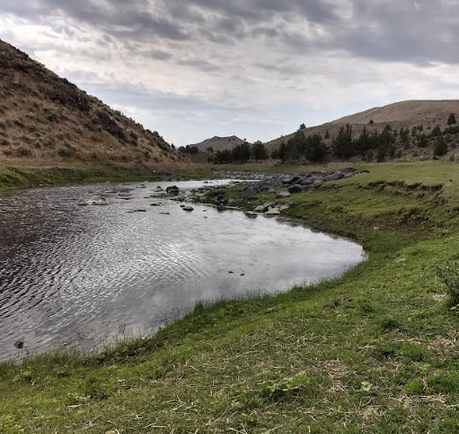

The Harney Soil and Water Conservation District (SWCD) is accepting bids on a monitoring project in Drewsey, Oregon. The SWCD will need a contract to set up and implement water quality monitoring along the Malheur River from Warm Springs Reservoir to Muddy Creek. Bids are due to Harney SWCD by November 14, 2025, by 12:00 PM. All work must be completed by January 31, 2028. More information and bid packets can be obtained at the HSWCD office at 530 Hwy 20 S, Hines, OR 97738, or on the district website, HarneySWCD.org.

The project is located in the upper Malheur River watershed in the community of Drewsey, Oregon. ODA has selected the Malheur River, Drewsey area in Harney County as a Strategic Implementation Area (SIA). The waterways within this SIA include the middle fork of the Malheur River, from its confluence with Muddy Creek downstream to Warm Springs Reservoir; Griffin Creek; Mule Creek; and Cottonwood Creek (see attached map).

Upon being awarded the grant, the contractor will need to:

1) Complete a Status and Trend monitoring plan with ODA, ODFW, DEQ, and OWEB to implement a monitoring plan. (See attachment #1)

2) Engage with landowners along the Malheur River to access the Malheur River on private land.

**BID SHEET**

**Malheur Strategic Implementation Area Monitoring**

**2026-2027**

**Schedule of Items**

|  |  |  |  |  |  |
| --- | --- | --- | --- | --- | --- |
| Description | Item No. | Qty. | Unit | Unit | Total |
|  |  |  |  | Price | Amount |
| Implementation of Monitoring | 1 |  | River Miles | $______ | $______ |
| Landowner Engagement | 1 |  | Hours | $______ | $______ |
| Collaboration and Coordination with Agencies | 1 |  | Hours | $______ | $______ |
| Total Quote  All or None |  |  |  |  | $______ |
|  |  |  |  |  |  |

|  |  |  |
| --- | --- | --- |
|  | Signature of Person Authorized to Sign | Date of Quotation |
| Contractor Name |  |  |
| Street Address | Signer Name (Type of Print) | Telephone Number |
| City, State, Zip | Title (Type or Print) | Email |

**REQUIRED ATTACHED ITEMS TO BE SUBMITTED WITH SEALED BID:**

* **Monitoring Plan Sample – Please provide a sample of a monitoring plan for this project using the template provided. It is known that changes will be made when more information is gathered and meetings with landowners and agencies are held.**
* **Progress Report Payment Request – Please specify if you wish to submit invoices for payment prior to final completion date.**

**ALL SEALED BIDS (EMAILED, MAILED, OR HAND DELIVERED), ARE DUE TO THE HARNEY SOIL AND WATER CONSERVATION OFFICE *BY NOVEMBER 14, 2025 AT 12PM*. Contents of the bid packet must be returned with a bid sheet.**

**Estimated start work date: December 2025**

**Contract Completion Time: Data to be collected and analyzed by January 31, 2028**

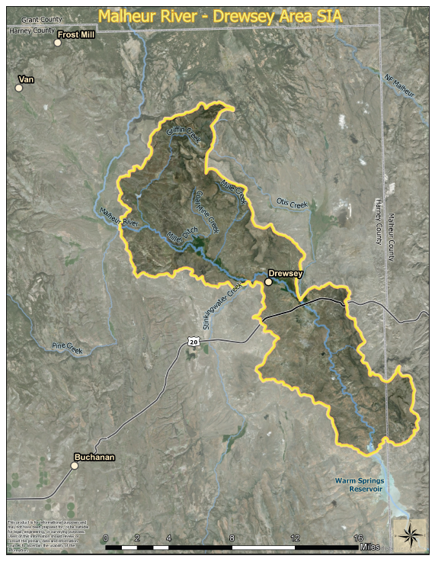

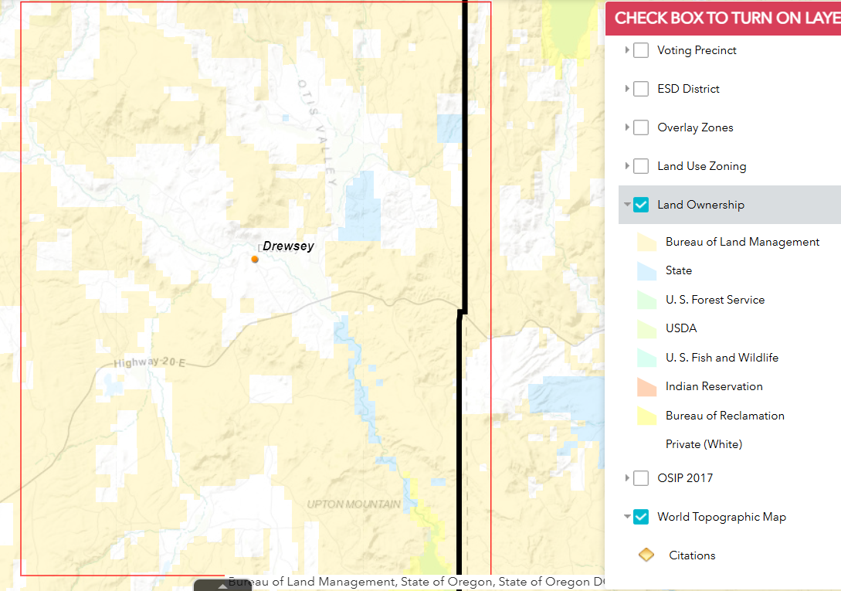

**SIA Monitoring and Assessment Proposal**

**SIA Monitoring Purpose:** SIA monitoring is NOT for compliance purposes. The purpose of SIA monitoring is to measure water quality and/or land condition in areas influenced by agriculture. SIA monitoring can include baseline data collection prior to implementing projects or improvements in farming practices. SIA monitoring can include monitoring necessary to identify the source of contamination. Data resulting from SIA monitoring will help demonstrate whether improvements in farming practices contribute to improvements in water quality and/or land condition over time. *The focus is on agriculture but can include other land uses.*

SIA monitoring includes both Status and Trend monitoring and Effectiveness Monitoring. Status and Trend monitoring is made at a regular interval to determine long-term patterns of a parameter and may involve collecting baseline data if none exists. The longer-term intention of SIA monitoring is Effectiveness Monitoring: to assess water quality before and after land management actions have occurred to measure effectiveness at either the project or watershed scale, equivalent to the scale at which actions are implemented. SIA monitoring may include vegetation/site assessments, stream temperature, sediment, bacteria, nutrients, or other parameters as appropriate to evaluate the results of improved farming practices and their relation to water quality.

SIA monitoring is a partnership between state natural resource agencies and local partners, with responsibilities outlined in this Monitoring Proposal Template document. ODA, OWEB, Oregon Department of Environmental Quality (DEQ), and Oregon Department of Fish and Wildlife (ODFW) are collaborating through a statewide Monitoring and Assessment Group (MAG) to provide guidance, templates, and training related to SIA monitoring.

1. **Project Title**

To be filled in prior to 1st Local Monitoring Team Meeting

1. **Applicant (Monitoring Lead-include name, title, address, contact info)**

To be filled in prior to 1st Local Monitoring Team Meeting

Local Monitoring Team Members (add interested parties to contribute to this Monitoring proposal)

|  |  |  |
| --- | --- | --- |
| Name | Organization | Title |
|  | ODA | SIA Monitoring Coordinator + the relevant Regional WQ staff |
|  | DEQ | Basin Coordinator |
|  | ODFW | Fish DB or Regional Habitat Biologist (Check with OFDW statewide water quality/mitigation specialist) |
|  |  |  |
|  |  |  |
|  |  |  |

1. **Map of SIA**

To be filled in prior to 1st Local Monitoring Team Meeting

Additional instructions:

* ODA to insert the initial SIA Assessment Map, which can be subsequently changed
  + This will help describe why the SIA was selected and where to focus efforts
* SIA grantee will prepare more detailed map as the monitoring questions are identified\
* May provide additional maps if relevant; i.e., historic and proposed monitoring sites

1. **Monitoring Background**

**Brief description of SIA (Location, terrain) including the following:**

To be filled in prior to 1st Local Monitoring Team Meeting

Additional instructions:

* List any towns and/or other notable features included within the SIA boundary
* River or waterbodies of concern

**Problem statement. Identify the anticipated agricultural and non-agricultural influences on watershed health and water quality within the SIA, and reference the information from the ODA assessment:**

To be filled in prior to 1st Local Monitoring Team Meeting

**Water quality parameters or habitat problem(s) of concern (what has been identified as the local issues?)**

To be filled in prior to 1st Local Monitoring Team Meeting

**Specific agricultural and non-agricultural practices/activities likely contributing to the concern (e.g. excessive livestock use of riparian zone, excessive erosion on steep cropped slopes),**

To be filled in prior to 1st Local Monitoring Team Meeting

**Planned activities per OWEB’s** [**Oregon Watershed Restoration Inventory**](http://www.oregon.gov/oweb/data-reporting/Pages/owri.aspx) **(e.g. riparian fencing, planting, cover crops). This information helps the monitoring reviewers understand what types of projects will be focused on. Reviewers understand that at the time of monitoring proposal development it is not likely that the SIAs have identified specific projects or landowners to work with yet.**

To be filled in prior to 1st Local Monitoring Team Meeting

1. **Summary of Available Data**

Summarize relevant available water quality data that is available to inform the need for the monitoring, and what data can be utilized in conjunction with this new data for interpretation. Provide a table or map of relevant stations, if possible.

To be filled in prior to 1st Local Monitoring Team Meeting

ODA to insert DEQ map from Integrated Report; which can be subsequently changed.

This data is largely filled out by the DEQ BC for the targeted area and relevant parameters

|  |  |  |  |  |  |
| --- | --- | --- | --- | --- | --- |
| **Summary of Available Data (Table can be modified)** | | | | | |
| **Station ID** | **Station Location** | **Sampling Year(s)** | **Parameter(s)** | **Results** | **Sampling agency/group** |
|  |  |  |  |  |  |
|  |  |  |  |  |  |
|  |  |  |  |  |  |
|  |  |  |  |  |  |
|  |  |  |  |  |  |
|  |  |  |  |  |  |
|  |  |  |  |  |  |

1. **Monitoring Parameters included in this Plan** – Surface Water, Ground/Soil Water, and/or Assessments

Please list the parameters that are intended to be monitored, and/or the type of assessment, if it is a landscape of field assessment.

1. **Monitoring Purpose** **of this Plan –**

*What is the primary purpose of the monitoring? (choose one)*

* **Status and Trend -** made at a regular interval to determine patterns of a parameter,
* **Effectiveness –** showing improvements over time of a parameter due to practices
* **Source –** determining where contamination originates
* **Assessment –** establishing core landscape data for prioritization, analysis and/or models

*What type of habitat are you monitoring? (choose one)*

* **Instream –** monitoring below the ordinary high water mark
* **Riparian –** monitoring above the ordinary high water mark
* **Upland –** monitoring above the floodplain
* **Wetland/Estuary –** monitoring on land with shallow water or tidally influenced

1. **Monitoring Questions**

The monitoring questions, scope and locations will be developed through discussion at 1st Local Monitoring Team, and in consultation with ODA’s Monitoring Coordinator and DEQ’s Basin Coordinator (representative to LMT).

# Example SIA Monitoring Questions:

Work with the MAG and Local Monitoring team to determine appropriate Baseline and/or Effectiveness Monitoring questions, considering local watershed conditions, data needs, and climatic trends.

Example Baseline questions:

Is XYZ Creek meeting the TSS targets outlined in the TMDL?

Status – Do summer stream temperature conditions exceed DEQ standards for salmonid rearing and migration (e.g., 18o Celsius, 7-Day Average of Daily Max) in selected SIA streams? How do these maximum 7-DADM temperatures vary across the watershed (location), in the downstream direction (e.g., headwaters to mouth, forest to agriculture to urban), and in targeted areas for potential restoration (e.g., riparian, stream habitat, fish passage) and/or protection (e.g., cold water refugia, designated conservation area)?

Trend - How do the summer maximum 7-DADM temperatures vary among years monitored in terms of peak years, lowest years, and peak timing? How do these trends in stream temperature compare to the 7-DADM air temperatures from the closest weather stations using the same analysis? How do these trends in stream temperatures compare to summer low-flow levels from the nearest gauging station (e.g., drought years, higher base flow years)?

Status and Trend - What are the TSS concentrations (mg/L) in XYZ Creeks during different seasons and flow amounts, such as summer base flow, storm flows with and/or without vegetation on trees, moderate flows between storm events with and without vegetation on trees, spring snowmelt, etc.? Do TSS levels vary by season, flow amount, types of flow events (spring snowmelt, summer thunderstorm, irrigation), and longitudinal location (headwaters, transport zone, deposition zone)?

# Example Effectiveness Monitoring questions:

Does reducing livestock presence in designated stream reaches and riparian areas in the SIA reduce bacteria concentrations to levels that meet Oregon and/or EPA standards within five years? If so, at what flow levels are these bacteria concentrations reduced (e.g., low flows, seasonal moderate flows, high flows during storm or snowmelt events?

Does reducing livestock presence on eroded/poorly vegetated stream banks in the SIA increase vegetated cover and reduce bare spots within five years? If so, what vegetation species are recovering and to what amount compared to pre-existing conditions (e.g., percent ground cover, percent canopy, trees/shrubs/grasses/forbs stocking per acre, etc., based on monitoring procedures)? Have TSS concentrations decreased over time from the treated area for different flow regimes (e.g., summer low flow, seasonal moderate flows, storm flows, irrigation flows)?

How much do riparian enhancement activities (e.g., fencing and off-stream watering, riparian planting and maintenance) increase percent canopy stream cover for the project reach on _____ Creek within 5 and 10 years? If canopy cover has increased, has the increase in stream cover resulted in decreased summer maximum 7-DADM temperature regimes from 5 to 10 years (i.e., status and trends over multiple years)? temperatures in Llewellyn Creek, Wood Creek, Weekly Creek, and Elk Creek within 5 years?

1. **Monitoring Methods and Design**

*What are the planned Monitoring Start and End dates?*

*Describe the seasonality and/or frequency of the monitoring, and why.*

*Describe who will manage the data and how it will be managed, and if it will be submitted to DEQ.*

*Describe analysis steps, including summary statistics to be used for each parameter.*

*Describe how you will report the results to conservation partners and the public.*

*Discuss Summary:*

*Discuss the relevant available data and how they relate to the monitoring questions. Provide information on how existing data can be used to help answer the questions and identify any data gaps.*

*If the monitoring question you are proposing to address is related to fish/habitat data, work with ODFW and other project partners to provide a short summary of relevant biological and/or habitat data.*

1. **New Data Needs and Data Collection**

Fill in the table below. If possible, include map with clearly labeled stream names and major features referred to in this document, such as reservoirs.

|  |  |  |  |  |  |
| --- | --- | --- | --- | --- | --- |
| **New Data Needs and Data Collection (Table can be modified)** | | | | | |
| **Station ID** | **Station Location** | **Parameter(s)** | **Number of Samples** | **Sampling Period** | **Why this Location?** |
|  |  |  |  |  |  |
|  |  |  |  |  |  |
|  |  |  |  |  |  |
|  |  |  |  |  |  |
|  |  |  |  |  |  |
|  |  |  |  |  |  |
|  |  |  |  |  |  |

1. **Proposed Budget**

Provide a budget showing the anticipated expenses for SIA monitoring using the following budget form.

|  |  |  |  |  |  |  |  |
| --- | --- | --- | --- | --- | --- | --- | --- |
| Task/Item | Unit Type | Unit Number | Unit Cost | Total | Match | | Total Costs |
| *Salaries, Wages and Benefits* | | | | | | | |
| Monitoring Coordinator, Reports | Hours | 20 | 53.23 | 1064.60 | - | $1064.60 | |
| Monitoring Coordinator, Field Days (12 days/yr, 2 yrs) | Hours | 192 | 53.23 | 10,220.16 | - | 10,220.16 | |
|  |  |  |  |  |  |  | |
| *Contracted Services* | | | | | | | |
|  |  |  |  |  |  |  | |
| *Travel* | | | | | | | |
| Monitoring Mileage (140 miles 14 trips, 2 years) | Miles | 3915 | 0.67 | 2623.05 | - | 2623.05 | |
|  |  |  |  |  |  |  | |
| Materials, Supplies & Equipment | | | | | | | |
| E.coli sampling supplies (14 sites,12 runs/yr+Dup) | Each | 180 | 12.45 | 2241.00 | - | 2241.00 | |
|  |  |  |  |  |  |  | |
| **Total monitoring** |  |  |  |  |  | **$16,148.81** | |

1. **Future Monitoring Planned or Anticipated**

*Describe any plans for the Local Monitoring Team to convene at least once per year throughout the SIA.*

*How will you use the results of SIA monitoring to inform future actions?*

*Describe any plans for future monitoring (note, SIA monitoring funds are available for up to 10 years).*