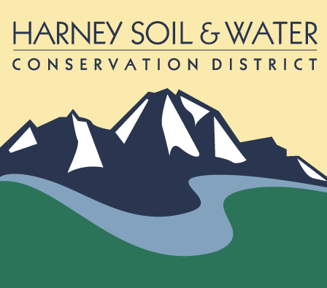

PO Box 848

530 Hwy 20 South, Hines OR 97738

Phone: 541-573-6446  [admin@harneyswcd.net](mailto:admin@harneyswcd.net)

**Harney Soil & Water Conservation District Regular Monthly Meeting**

**February 22, 2024**

**Historic Central Hotel**

Note: this meeting took place prior to the annual business meeting.

Present: Board Chair (BC) Jeff Hussey, Vice Chair (VC) Scott Franklin, Board Directors (BD) Susan Doverspike, Ken Bentz, Stacy Davies; District Managers (DM) Jason Kesling; HSWCD staff Breanna O’Connor, Sam Artaiz, Danielle Reynolds, and Admin Assist (AA) Barbara Pearson

Absent: Secretary/Treasurer Ryan Peila, BD Carol Dunten

BC Hussey called the meeting to order at 5:03 pm.

**Item #1: Approve Meeting Agenda (action item)**

DM Kesling advised of an agenda addition (request for a special meeting in March for a juniper contracting bid selection). BD Doverspike moved to accept the agenda with the addition; BD Bentz seconded. The motion was approved by all present who were eligible to vote.

**Item #2: January Financial Report (action item)**

The January financial reported was included in the board directors’ notebooks. DM Kesling said reimbursements are being received. BD Bentz moved and BD Doverspike seconded approval of the report. The motion was approved by all present who were eligible to vote.

**Item #3: January Meeting Minutes (action item)**

There were no additions or corrections suggested. BD Doverspike moved and BD Bentz seconded approval of the minutes. The motion was approved by all present who were eligible to vote.

**Item #4: LGIP investment Update and Request (action item)**

DM Kesling said the fund is performing well; the first report showed it accrued about $335 in interest, which he felt was a pretty good return on investment. He requested the board approve moving additional assets into the fund. He said the funds can be pulled out whenever desired. The fund will be shown on financial reports as a separate bank account but the board will be able to see balances within the monthly financial under the original class ID. BD Bentz asked if the fund was FDIC insured and was advised yes. DM Kesling offered to go through each line item. He said HB funds won’t be spent until 2025 and requested a portion of those funds be moved into LGIP. This will be reflected in the Bank of Eastern Oregon account going from $400K to $300K (operating balance between $200K to $150K). BD Davies moved and BD Doverspike seconded approval of moving additional funds into the LGIP. The motion was approved by all present who were eligible to vote.

**Item #5: SWCD New Position “Conservation Planner” (action item)**

DM Kesling explained the background for the financial availability for the position: The High Desert Partnership recently received $2.5M, of which HSWCD will receive a portion; SONEC Sam Artaiz created proposals for the funds; $60K of staff would be for the district’s portion and the rest would be for CCAA. He requested the board approve the conservation planner job description and pay scale (included in the director notebooks)—the salary will be between Step 1 and Step 3. BD Doverspike discussed a meeting she had attended earlier regarding the “Buy America” promotion—infrastructure money will have a lot of flexibility, which was tied into this discussion. She explained the new program, adding inflation is not taken into account. There were no questions. BD Davies moved to approve the creation of the job position and accept the suggested pay scale. VC Franklin seconded. The motion was approved by all present who were eligible to vote.

**Item #5b: Request for Special Meeting in March (consensus)**

Note: During the January meeting, the board approved canceling the regular board meeting since it would be during calving season. DM requested a special meeting be scheduled for the board to accept and award bid(s). The bid tour will take place March 5, 2024 and bids must be submitted no later than March 13, 2024 at 4 pm. He requested a special meeting to take place sometime between March 14-21.

Discussion led to the consensus to schedule the special meeting for March 15, 2024 at 3:30 pm. The meeting would be held remotely.

DM Kesling said the project will comprise 4200 acres. BC Hussey asked if there is the possibility of the project including more than one contractor, and DM Kesling said that decision would be up to the board. Contractors are required to attend the tour. BD Bentz asked if there is any way to encourage as many contractors to bid and participate as possible. DM Kesling said there will be another bid coming up (Mule Creek). He said while the meeting will be remote the board directors will need to submit score sheets for the record.

The meeting ended at 5:20 pm but did not adjourn due to the annual meeting.

Respectfully submitted,

Barbara Pearson, Admin Assist

|  |  |  |
| --- | --- | --- |
| _____________________________________ |  | ____________________________ |
| District Representative |  | Date |