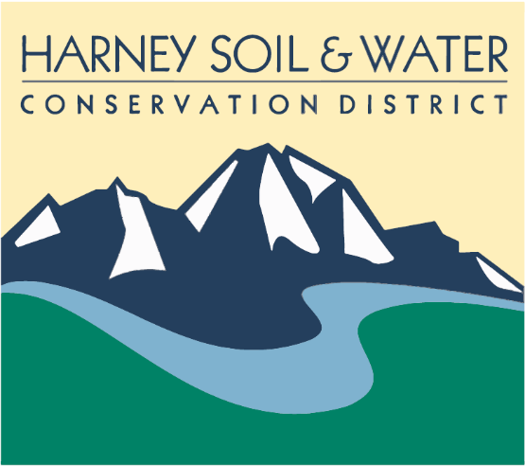 | Harney Soil & Water  Conservation District  PO Box 848  530 Hwy 20 South, Hines, OR 97738  Phone: 541.573.6446  Email: admin@harneyswcd.net

What: | Annual Meeting
When: | Thursday, February 26, 2026
Time: | 6 pm
Where: | Historic Central Hotel, 171 N. Broadway, Burns

Meeting Content
5:30 pm | Open doors, social time, get food
6:00 pm | Call meeting to order
6:05 pm
6:30 pm | Prizes
6:40 pm | SWCD 2025 Audit Report—Robert Gaslin, Gaslin Accounting
6:50 pm | Prizes
7:00 pm | District Manager presentation
7:20 pm | Prizes
7:30 pm | Recognition/Roundtable
8:00 pm | Adjourn

